Meeting Notes

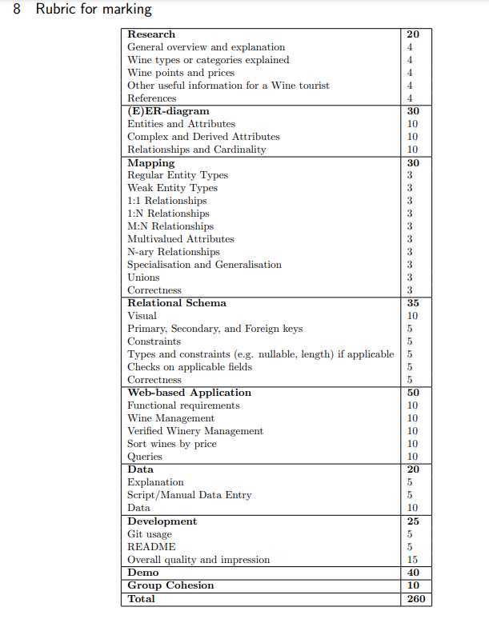

Front end:

Javascript, call API and populate.

Management tab.

Add Images to wineries form API call should be easiest or manually add them there aren’t _that_ many.

Login and manage users • Manage wines, and wineries. • Manage sites, addresses, and locations • Sort wines by quality, price, etc. • Update the database and/or extend, delete, etc. • Suggest best destinations based on location.

Back end:

Sort by: Price percentile, rating percentile, price (normal price takes priority from low to high and from high to low)

Query for is in what location; display wines from certain wineries; filter by grape type; filter by user rating or quality.

To be included in power point (we have 20 min to demo I don’t think the PowerPoint should take more than 10 minutes to go through):

Other Changes / to implement:

Complete research, see spec (one page)

Relational Schema: add checks and constraints, remember to specify how updates, and deletes affect relations.

More South African focus.